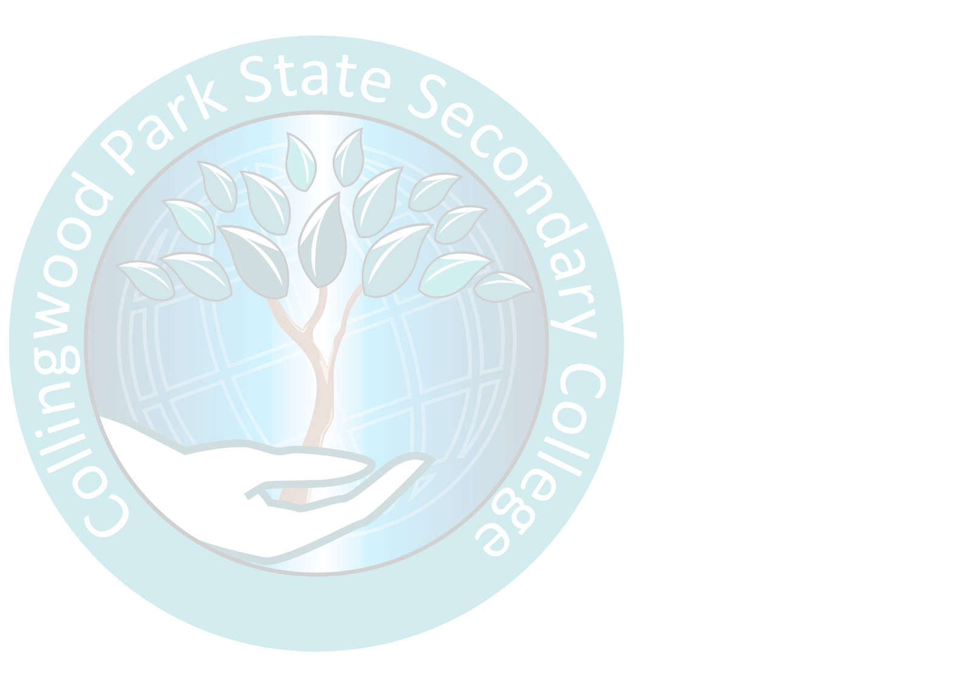



For questions:

[byox@collingwoodparkssc.eq.edu.au](mailto:byox@collingwoodparkssc.eq.edu.au)

07 3818 5888

Collingwood Park State Secondary College BYOx Charter

# BYOx

In today's rapidly evolving digital landscape, the ways in which we learn, access, and share information are transforming. Recognising the increasing importance of engaging with external content, collaborating effectively with peers, and mastering advanced technologies, Collingwood Park State Secondary College is dedicated to preparing our students for the future.

Our Bring Your Own 'x' (BYOx) Program embodies this commitment by fostering digital literacy, enhancing educational experiences, and equipping students with the essential skills to thrive in the 21st century. As part of this initiative, students will be required to bring a laptop for use at school. Please see below, for the recommended specifications of student devices.

# BYOx Minimum Specifications Required

|  |  |
| --- | --- |
| Laptop | * Intel Core i3 9th Generation or newer * 1 x 8GB DDR4 RAM * 128GB SSD * 12-15" FHD 1920 x 1080 resolution screen |

# BYOx Recommended Specifications

|  |  |
| --- | --- |
| Laptop | * Intel Core i5 11th Generation or newer * 1 x 8GB DDR4 RAM or more * 256GB SSD * 12-15" FHD 1920 x 1080 resolution screen |

Frequently Asked Questions

**Is there a cost to use our BYOx network?**

No, there is no cost as of 2026. For students to have access to the BYOx network, parents/guardians must read and sign the BYOx Responsible Use Agreement below.

**Do I need to purchase Microsoft Office?**

No, the Department of Education provides a fully paid version of Microsoft Office 365 to all students. More information on that can be found on the school website or by calling the school.

**My device has been damaged at school, who is responsible?**

The school does not provide any ICT services beyond the connecting of devices. Any damage (intentional or otherwise) is a behaviour management issue and will involve the school and parents. Parents are highly encouraged to purchase insurance or Accidental Damage Policies through your IT supplier.

**Can a BYOx device be charged at school?**

The school does not allow students to charge devices, this is due to the trip hazard and potential fire/ electrical risk from a charger being plugged in. Chargers may be confiscated if found in use.

**What is involved in connecting a BYOx to the school network?**

Once you have signed and submitted your BYOx Responsible Use Agreement, you will have access to begin the BYOx "on-boarding" process. Student devices can then be connected at home using the instructions available on our school website.

# BYOx connection request and Responsible Use Agreement

This document must be signed and returned before access to the BYOx Gateway will be provided. You will need to **return this form** to the on-site Information Technology officer for approval.

|  |  |  |  |  |  |
| --- | --- | --- | --- | --- | --- |
| **Parent /Guardian– First name and Surname** | |  | | | |
| **Student – First name and Surname** | |  | | | |
| **MIS** ID e.g. flast1 |  | | | **Year Level** (circle) | 7 8 9 10 11 12 |
| **Private Laptop Details** | | | | | |
| **Make and Model** e.g. Dell Latitude e6230 12.5 | | |  | | |
| **Serial Number** (Usually found on the bottom of the laptop) | | |  | | |

When using a privately owned laptop at Collingwood Park State Secondary College, or connecting it to the school network, we (Parent/Guardian and Student) agree that:

* I have read and understood the ICT Responsible Use Policy (found at collingwoodparkssc.eq.edu.au)
* I agree to abide by the guidelines outlined by the policy.
* I am aware that non-compliance or irresponsible behavior, as per the intent of the BYOx agreement and the ICT Responsible Use Policy, will result in consequences relative to the behaviour.
* The device must at all times be connected to the BYOx Gateway when on school premises and in use. When connected to the BYOx Gateway, all activities will be logged. School ICT guidelines are to be followed in accordance with the completed and signed school ICT Agreement (signed on enrolment).
* The device will only be used for educational purposes when connected to and using school services.
* Collingwood Park State Secondary College will only provide technical support to enable connectivity to the school network via the BYOx Gateway, for access to student files required for class, internet and printing services. This may require school technical support staff to amend laptop settings.
* It is the responsibility of the student to ensure that the private laptop is secured when not in use. Collingwood Park State Secondary College takes no responsibility for theft, loss, vandalism, damage or unauthorised access to private laptops. A laptop carry case is recommended.
* BYOx devices must not be charged using school power outlets or by plugging into school owned computers. All private laptops must be brought to school fully charged.
* BYOx devices must contain a virus scanner with up-to-date data virus definitions (included with all new Windows 10/11 devices)
* It is the responsibility of the student to back up data on the private laptop e.g. to external hard drive; USB; or OneDrive.
* Any software purchased under Education Queensland agreements must be removed from the private laptop as per the conditions of the agreement. Any privately owned software installed on the laptop must be age appropriate, follow copyright legislationand not cause offense.
* Parental/Guardian permission will be sought for students to utilise third party services that may collect student data or store student works. This permission will be granted through the *Online Services Consent Form*.
* Collingwood Park State Secondary College and the Education Department reserves the right to restrict access and use of any private laptop used on the school grounds, whether it is connected to the school network or not. Access to the school network and permission to use the private laptop on school grounds will be withdrawn as a consequence of any inappropriate use and/or security breach.
* OneDrive (Education Queensland Account) is the only cloud-based service to be used to store, send or access information. Other cloud-based services such as iCloud or Dropbox must not be used.

|  |  |  |  |
| --- | --- | --- | --- |
| **Parent Signature:** |  | **Parent Name:** |  |
| **Student Signature:** |  | **Date:** |  |
| **IT Signature** |  | **Date:** |  |

*Note: If the above device is substituted, a new BYOx Connectivity Request form will need to be completed and signed prior to connection of the new device.*